DHIS 2 Geostat
User Documentation

Register shape files

Create a link between the GIS application and the shape file by filling out this form:
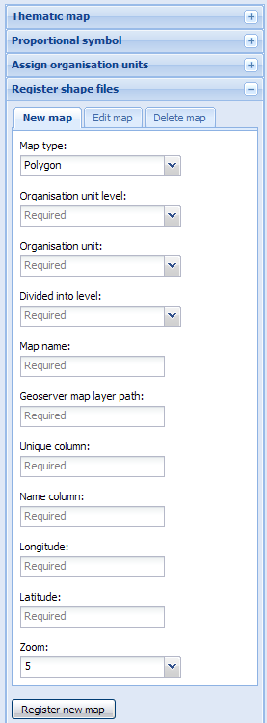
- Map type
Polygon or point (e.g. health facilities)
- Organisation unit level
The level of the organisation unit which contains the polygons. Usually the lowest level available (national level).
- Organisation unit
The organisation unit which contains the polygons. Usually the entire country:
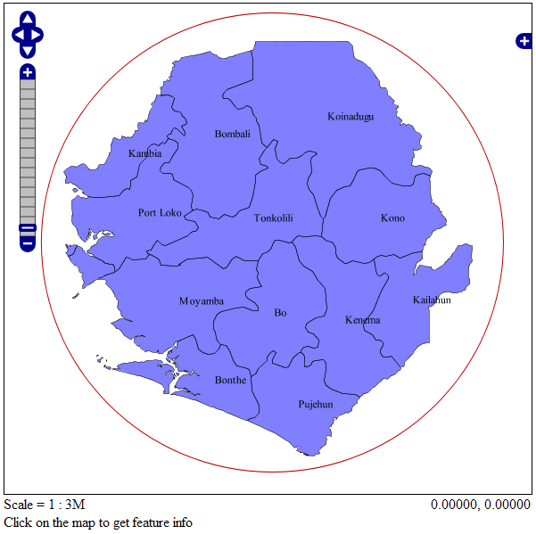
- Divided into level
The level of the organisation units into which the map is divided:
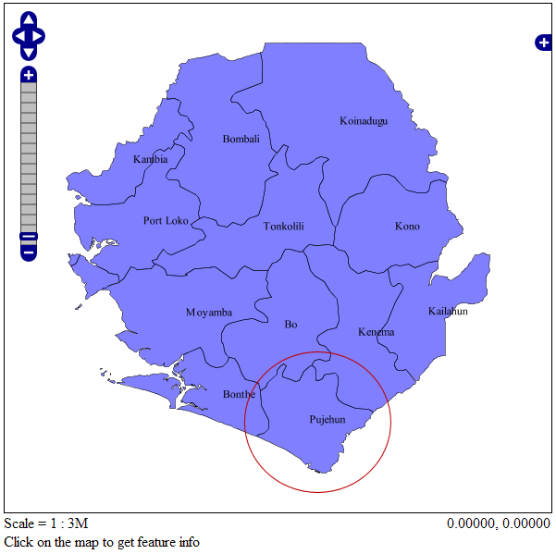
- Map name
Give the map whatever name you would like. This name will appear in the map lists.
- Geoserver map layer path:
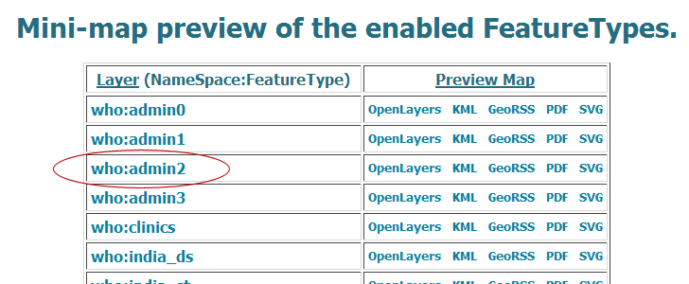

- Unique column
The shapefile column that holds a unique value for the organisation unit (e.g. the name):
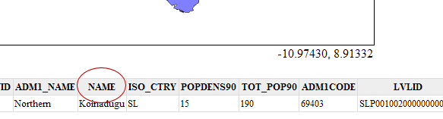
- Name column
The shapefile column that holds the name of the organisation unit (in this case the same as above). Will appear in the information box:
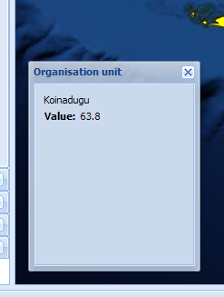
- Longitude / latitude
In Geoserver, put the mouse in the center of the map and note the coordinates. One decimal is sufficient, i.e. in this case -11.8 and 8.5:
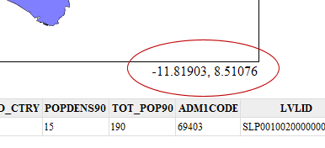
- Zoom
Depends on the shapefile. 7 is usually appropriate.

Assign organisation units

Choose a registered map og click load map. The organisation units in your database on this level will appear in the list and colors will appear in the map. Create a link between an organisation unit in the database and the respective organisation unit in the map by first clicking it in the list and then in the map. A confirmation will appear in the bottom status panel. Click the button again to update the list and the map – this is not required, but will tell you which organisation units are and are not already assigned.
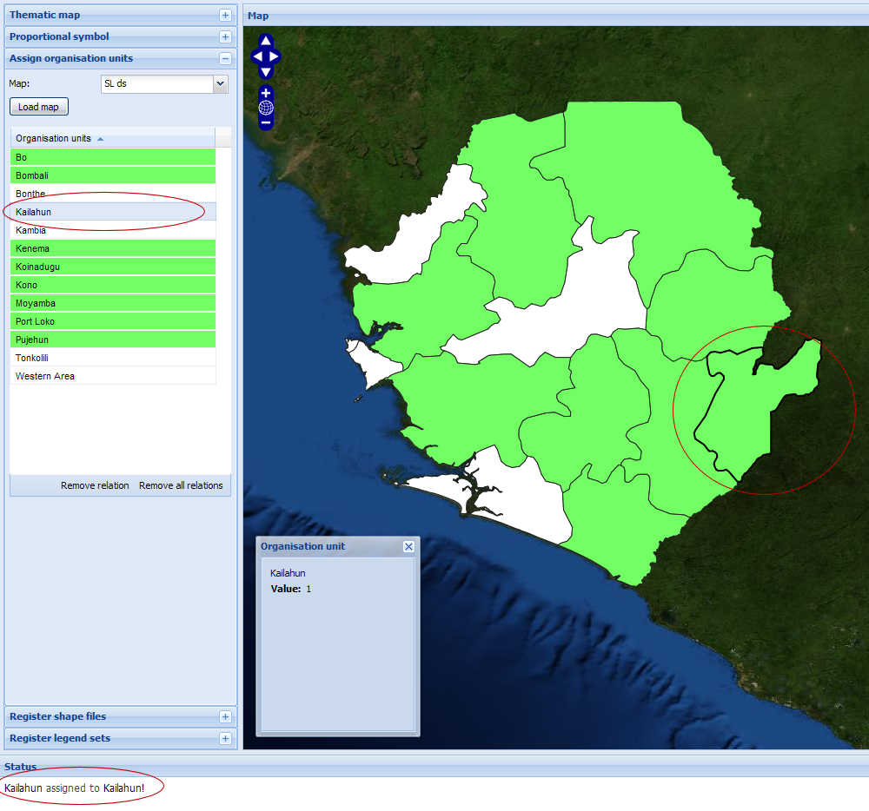

Legend sets

A legend set is predefined colors connected to an indicator. When this indicator is selected in the thematic map, you may select the appurtenant legend set and the colors will be automaticly set. The name will appear in the legend set combo box.
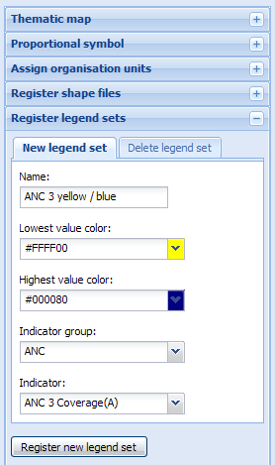

Thematic map

After exporting data from DHIS2, you may select indicator, period and map (level) to put colors on top of the shape file:
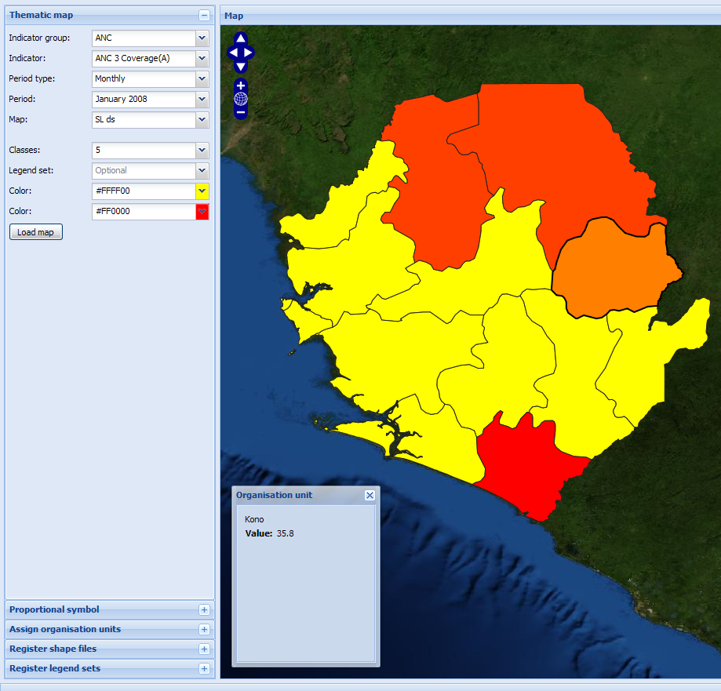

If you have created a legend set for the selected indicator, simply select it in the legend set combo box. The two color boxes will be given the new colors automaticly.Click load map to re-color the map.
